Engineering success
Published Apr 11, 2012 at 2:24 pm (Updated Apr 11, 2012)

- 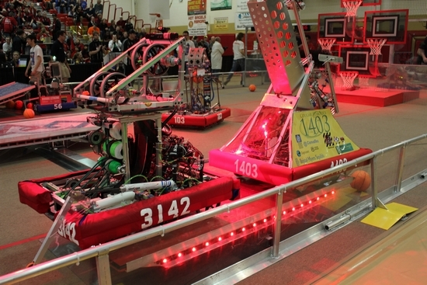
Photos Provided Team Aperture's robot

- 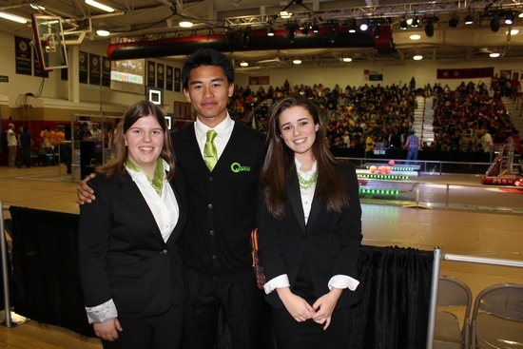
From left: Team Aperture members Magda Dworzycki and Mohammad Balatero, both of Newton, and Tess Bugay of Green Township, wrote the award submission and gave the presentation that won Team Aperture the prestigious FIRST Engineering Inspiration Award.

Newton High School robotics team wins Engineering Inspiration Award at recent competition
NEWTON — Newton High School’s robotics team lost in a nail-biting final match at the recent regional championship for FIRST Robotics (For Inspiration and Recognition of Science and Technology) at Mount Olive High School in Flanders, coming up one point short of winning the regional title in the final round.
However, the loss was softened when Team Aperture was awarded the prestigious Engineering Inspiration Award, recognizing the group’s efforts to educate their school and community about STEM (Science Technology Engineering and Mathematics).
With demonstrations at schools, the New Jersey State Fair, earning varsity status and their assistance with the NASA Downlink Exposition 30, Team Aperture 3142 is poised to bring even more accolades to their school and community in upcoming competitions.
“This is the second biggest award presented at the competition and as we are only a three-year-old team, this is huge,” said Jim Hofmann, technology teacher at Halsted Middle School in Newton and coach of the Newton High School FIRST Robotics team. “The Engineering Inspiration Award celebrates outstanding success in advancing respect and appreciation for engineering and engineers, both within their school, as well as their community. Our dedicated efforts to become the first public school in New Jersey to get varsity status for an academic team have not gone unnoticed and it feels really good.”
The team was also awarded #1 Pit Safety Recognition Award and earned an invitation to the Mid-Atlantic Robotics Regional Championship to be held April 12-14 at the Liacouras Center at Temple University in Philadelphia, Pa.
“We worked really hard at getting a successful alliance and we all worked very well together. Getting to the final was hard work and great fun,” said Rich Gerdes, a senior at Newton High School (NHS) and member of Team Aperture. NHS teamed up with Team 1403 of Montgomery High School and Team 103 of Palisades High School in Pa for the competition held Saturday and Sunday.
About a month ago, Team Aperture was presented with a coveted invitation to the FIRST World Championship to be held April 25-28 in St. Louis, Mo. This advanced invitation is very unique and representative of all the great things going on in NHS robotics, said Hofmann.
To make the trip to the international competition, the group needs to raise an estimated $30,000. To date, with the cooperation and support of the Newton community, the team has raised just over $7,000.
With the invitation to compete again in Philadelphia, the team finds itself even further behind the fundraising eight-ball.
“It is so exciting to be earning the opportunities, but without enough funding, we may not be able to attend,” said Hofmann, who noted that team will need to raise another estimated $2,500 to attend the regional championship. "We just learned that we have been awarded a MAR Mid-Atlantic-Robotics grant late yesterday for $4,000 to attend the Philadelphia championship. Being a young team, the group doesn’t have the deep coffers that some more experienced teams do. While they have worked tirelessly at finding corporate sponsorships and grants and the community has been extremely supportive, the fundraising hurdle is huge."
This will be the group’s second trip to the World Championship. In 2010, the team won the FIRST Rookie All Star Award at the New York City Regional competition and earned a trip to the national event in Atlanta, Georgia.
“It breaks my heart to think that we may have to choose not to attend this event because we don’t have the funding," said Hofmann. "Without the financial backing, we may have to pass our invitation on to another team. The kids worked so hard to be in this position. That real possibility would be a missed opportunity.”
To help the Newton High School FIRST Robotics Team, contact Hofmann at Halsted Middle School,
973-903-9774.

