Excitement reigns at robotic competition
PUBLISHED MAR 27, 2013 AT 2:27 PM

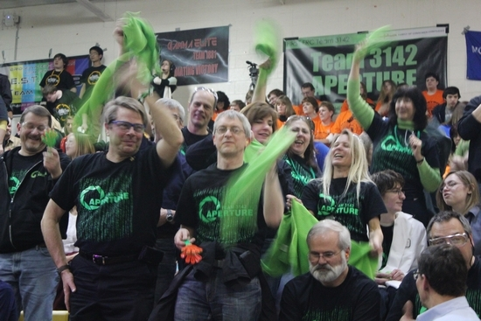
The crowd cheered wildly for Newton FIRST Robotics team.

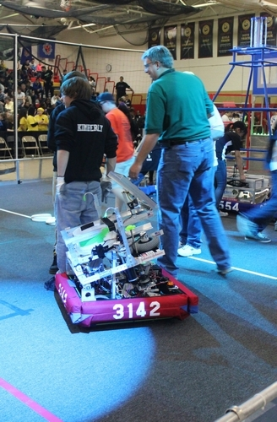
Robot built by Newton FIRST Robotics Team 3142

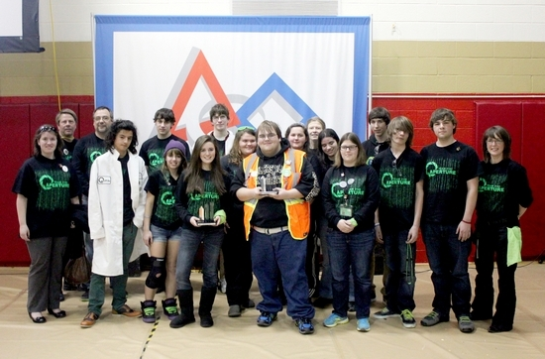
Newton FIRST Robotics Team 3142

NEWTON — Nick Aquilino a senior from Newton High School was honored with the Star of The Day on Sunday at the FIRST Robotics Competition in Mt. Olive.

He brought home the Underwriters Laboratories Industrial Safety Award for the team during the awards ceremony. This is the first time this young team has earned this award. "I am thrilled for Nick. I love how FIRST has given him a path in life," said Paul Hiler from J&J, a long time mentor of the team. Nick has accepted an invitation to Millersville University and will be majoring in Occupational Safety and Environmental Health.

Aperture 3142 will be attending the Regional event at Leigh University on Friday, April 12 through Saturday,, April 13 to compete for the Engineering Inspiration Award, the second most prestigious award available to FRC teams.

Team members Captain Tess Bugay and Project Manager Todd Schabacker will be competing for the Dean's List Award which honors a student who demonstrates leadership and commitment to the ideals of FIRST, overall individual contribution to their team, technical expertise and passion; entrepreneurship and creativity, are able to motivate and lead fellow team members, and are effective at increasing awareness of FIRST in their school and community.

Their coach James Hofmann has been nominated for the Woodie Flower's Award, an award presented to a mentor or coach for their exceptional service. Winners of theses awards as well as the winning alliance and the Chairman's Award will move forward the International Competition in St. Louis to compete against the best team in the world.

Something for everyone at the competition last weekend, teams from Pennsylvania and New Jersey came together to compete against, and with, each other for recognition as the top alliance and earn prestigious awards in the FIRST Robotics Competition in Mt. Olive.

With robots reigning supreme, the crowd was treated to some action-packed technical feats. Robots swept up Frisbees from the ground and fired them like bullets from a machine gun.

Frisbees riddled the air, found their targets, and racked up points for each team and their alliance.
But it was the last 30 second of each match that everyone waited for.

The pyramid. The Ultimate Ascent. In these last seconds offensive teams scrambled to position themselves at the base of a pyramid while defensive teams maneuvered their robots to block access to the bottom rung.

Once in position though, teams held their breath hoping that their climbing mechanism, wiring, or programming wasn't damaged during the match. Then the climb. Many robots pulled themselves up on the first rung garnering ten points for their alliance. For the crowd this weekend, and the young first time visitors from Green Hills School, it was the climb to the top of the pyramid that had everyone on their feet cheering. RoboRaiders Team 75 from Hillsborough climbed to the top of the pyramid collecting the coveted, and remaining, 30 points available in the match.

Enjoying the matches is just part of the competition experience. Teams donning spiked orange hair, Egyptian robes, and white lab coats, as did Newton FIRST Varsity Robotics Team 3142, dance in the aisles, wave team colored towels and banners, shake noise makers, and do the wave in support of their favorite teams and alliances.

For the youngest of visitors, Newton's Aperture 3142 hosted a story time, reading Benjamin McFadden and the Robot Babysitter, and gave new attendees tours of the Pit Area, where they collected custom designed buttons made by each team for the competition, visited the playing field, and explained this years game challenge and the importance of safety.

Skylar Grosche from Green Township, heard about the event when Aperture 3142 visited Green Hills School and invited students to wear their black and green colors to come cheer them on at the Mt. Olive competition.

Skylar was a first time visitor to the FRC competition and after her tour Skylar told her tour guide, "I sooo, want to grow up and be on a robotics team and build robots!"

