Girl Scout awarded Medal of Honor for saving a life
Posted: Jun 03, 2012 11:20 PM EDT Updated: Jun 03, 2012 11:20 PM EDT

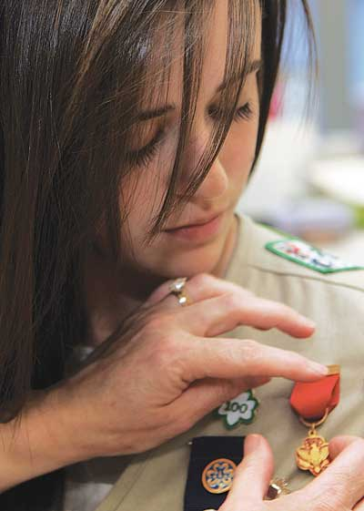
Photo by Lauren Scrudato/New Jersey Herald - Laura Bugay pins the Medal of Honor on her daughter, Tess, 16, an honor she received for using the CPR and first aid training she completed as a Girl Scout to save a woman’s life while on a family vacation.

NEWTON — After hiking up a glacier on the first day of her family vacation to Anchorage, Alaska, last August, Tess Bugay, then 15, was bone cold and in desperate need of relaxation.
By BRITTANY SODA
newsroom@njherald.com
NEWTON — After hiking up a glacier on the first day of her family vacation to Anchorage, Alaska, last August, Tess Bugay, then 15, was bone cold and in desperate need of relaxation. While her dad, John, parked the family's rental car, Bugay journeyed to the hotel's hot tub with her mother, Laura, and brother, John, then 11. One day into her two-week vacation, Bugay was not thinking too far ahead. She wanted to experience Alaska one moment at a time, and "live in the moment," she said.
Unexpectedly, the expression "live in the moment" took on a different meaning for Bugay, as she quickly propelled from carefree thoughts about what she wanted for dinner to urgent recollection of her CPR training.
While leaving the hotel pool area, Bugay and her family spotted a woman floating face down.
As a Girl Scout for 11 years, Bugay, of Troop 720 in Green, never thought she would have to use the CPR and first aid training in which she had been certified twice. Certification was just part of various Scout merit badges she had worked on over the years. Her first certification came while taking a baby-sitting class with her sister Scouts so they could raise money for a trip to Savannah, Ga., to see the birthplace of their founder, Juliette Gordon Low. Using cookie money raised door-to-door, the girls of Troop 720 updated their certification so they would "Be Prepared," never believing that they might really have to use it.
After spotting the woman, Bugay asked a little girl who had been swimming if the woman was OK. The little girl looked puzzled, but gave no clear answer. No lifeguard was on duty — although there was a "swim at your own risk" sign — so Bugay sprang into action. Having just finished a season on the Newton High School swim team, Bugay dove into the pool and swam to the woman. Reaching the woman first, she pushed her to the side of the pool where her mother and a man, who saw the family rush to action, helped maneuver the woman onto the deck. Her brother, a Boy Scout from Troop 184, ran for help at the aerobics facility near by.
"From that moment on, I had a warped sense of time," Bugay, now 16 and a sophomore at Newton High School, recalled on Thursday. "Time slowed down in that moment. I was very focused."
After assessing the situation with her mother and the man who had helped her carry the woman on to the deck, the three began CPR and revived the woman; as EMTs arrived the woman began showing signs of life.
"The things you think you'd remember are not the things you actually remember," Laura Bugay said, about the event. Together, the vacationers were able to save the woman's life.
Tess Bugay stayed completely calm and logical until after the EMTs took the woman to the hospital.
"Shock finally took over and tears streamed down my face. (I) experienced floods of emotion — adrenaline, shock, happiness and helplessness," Tess Bugay said.
At unexpected times, seemingly innocent events trigger memories of the incident for Tess Bugay. Most recently, while washing her hands, she felt the cool water and was brought right back to that day in August.
"I can't imagine going through that not knowing what to do. You would have to stand there, paralyzed," she said.
Thankfully, through her Girl Scout training, she knew what to do and was able to save a life.
For saving the woman's life, Tess Bugay was presented the Medal of Honor by Chief Operating Officer Betty Garger and Chief Executive Officer Helen Wronski from the Girl Scouts of Northern New Jersey on May 9.
The Medal of Honor is awarded to registered Girl Scouts who save a human life or attempt to save a human life under circumstances that indicate heroism beyond the degree of maturity and training to be expected at their age. The local Girl Scout council judges whether an act qualifies for a lifesaving award,
Her brother, John, will receive a similar award through the Boy Scouts for his help during the incident.
Statistics show that one out of every 100 Girl Scouts will at some point in their lives use what they learned in Girl Scouting to save a life, according to the Girl Scouts of Northern New Jersey.
Tess Bugay shares the skills she has learned through Girl Scouts with nearly everyone she meets.
In March, Bugay's Girl Scout troop helped facilitate a CPR and first aid certification class for the Newton FIRST varsity robotics team where Bugay was certified once again. The robotics team, just finishing its third season, now has eight members currently trained in CPR and first aid. Next year, Bugay hopes to help her robotics teammates increase that number by offering classes to the incoming team members.
"I am thankful to be a Girl Scout in every way, shape and form. Without Girl Scouts, I would not be the person I am today," she said.

