Students’ engineering skills put to the test
Posted: Mar 17, 2013 10:25 PM EDTUpdated: Mar 17, 2013 10:25 PM EDT

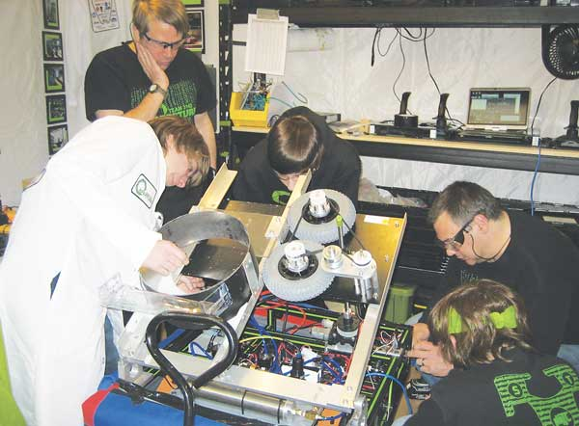
Submitted photo - Members and advisers of the Newton FIRST robotics team work on their robot during the first regional robotics competition in Trenton March 16.

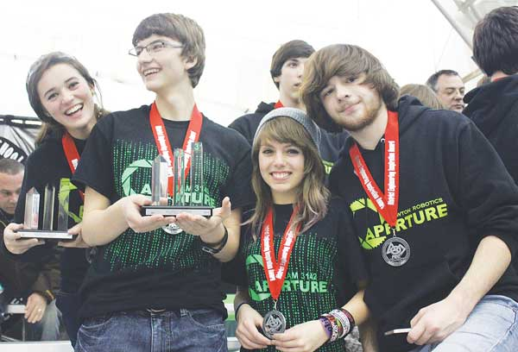
Submitted photo - Members and advisers of the Newton FIRST robotics team pose with their first place Engineering Inspiration trophies and medals during the regional robotics competition in Trenton.

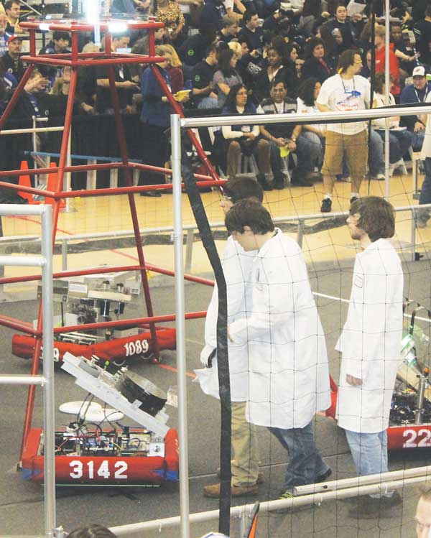
Submitted photo - Members of the Newton FIRST robotics team walk their robot into the arena.

By BRUCE A. SCRUTON
bscruton@njherald.com
NEWTON — When the offense failed and the Frisbees didn't fly, the robot team moved into defensive mode, keeping the other side's robots from getting off shots with their own flying discs.
"Not well," was Jim Hofmann's assessment of the Newton High School robotics team's first competition this past weekend at a regional tournament in Trenton. "But they played very well defensively."
This is the fourth season that Newton has fielded a robotics team — recognized as a varsity sport at the school — in the For Inspiration and Recognition of Science and Technology (FIRST) program.
Each year the teams are given an outline of what the robot must accomplish and during competitions, alliances of three robots from different teams work cooperatively against a similar team.
This year, the robots have to launch Frisbees at various-sized targets while working to keep the other teams' robots from scoring points. The playing field includes two pyramids in which the targets are contained but which the robots can score "bonus" points by climbing in the last 30 seconds of the round.
A full weekend of competition includes each robot working through a series of rounds with various other teams, amassing points for tournament awards.
Overall, Hofmann said the Newton team finished about 19th in the field of 39 teams from New Jersey and Pennsylvania.
But there are also awards for other aspects and Newton came home with the Engineering Inspiration Award, given to the team that is judged to have the best outreach program. Among other things, Newton was recognized for its help with other schools drawing them into the FIRST program.
Also fielding robot teams this year are Pope John, Vernon and Jefferson high schools.
Pope John competed in Trenton, but did not finish in trophy position.
All four teams will be in the next regional competition this coming weekend sponsored by Mount Olive High School. Competition will be from 8 a.m. to 5:30 p.m. Saturday and Sunday.
"We'll have it all together for Mount Olive," said Tess Bugay, a junior and captain of this year's Newton team.
She said all the team's problems "happened that day," and said it was a programming error that failed.
Hofmann said the pneumatic system that fires the Frisbees is controlled by computer software that was wiped out.
One of the limitations placed on teams is the limited amount of time they have physically working on the machine.
For instance, this week, the team is allowed just six hours and Hofmann said it would probably end up being two hours later today and four hours on Wednesday.
But the team can work on designing and manufacturing parts. The coach said the team will be working on its vision targeting system for throwing the discs as well as the climbing devices.
Nick Aquilino, a senior on the team, was honored for his work on team safety.
Among other things, he helped design a coloring book focusing on safety, which was part of the team's outreach.
"I also have a first aid program covering various things that could happen," he said.
Aquilino has been accepted to Millersville University where he will pursue a degree in occupational safety and environmental health.
"Since I was a sophomore, I've been the team's safety officer," he said. "I think that's what got me interested; that and I've always been inclined to help people, seeing that they don't get hurt."
Last year, the Newton team made it to the world finals in St. Louis and Hofmann said he believes the team can make a repeat appearance again this year.
At the Mount Olive weekend, Newton is in the running for the Chairman's Award, the top outreach award, which would bring automatic entry to St. Louis.
The team can also qualify through the New Jersey-Pennsylvania regional competition to be held in mid-April at Lehigh University.

