Robotics team makes it to regionals
PUBLISHED MAR 18, 2013 AT 4:15 PM (UPDATED MAR 19, 2013)

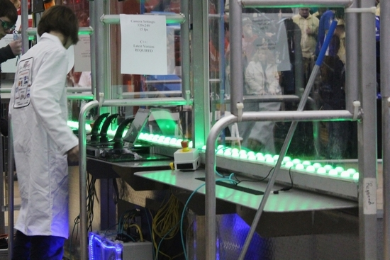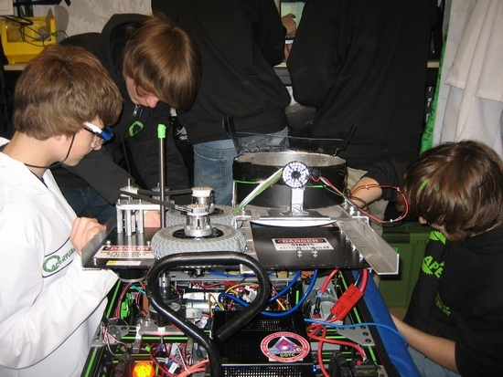
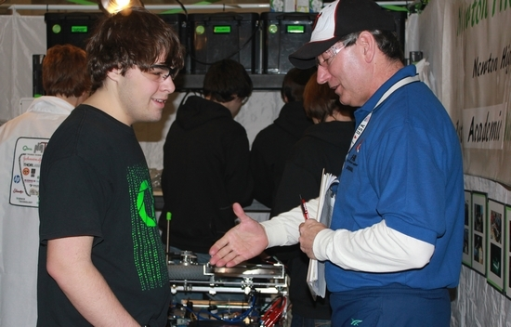
NEWTON — After an intense six week build, Newton FIRST Varsity Robotics arrived at TCNJ (The College of New Jersey) ready to throw Frisbees, show off their robot SnAperture, and compete for the top awards in the FIRST Robotics Competition district event.
With 15 judges interviewing the 37 teams for excellence in everything from innovation and robustness-of-build to team spirit, Aperture 3142 team members impressed the judges with their technical knowledge, innovation, industrial safety preparedness, educational and service outreach, as well as their ability to demonstrate an understanding of the FIRST organization's goals and make it their mission to spread the message of STEM (Science, Technology, Engineering, and Mathematics).

The team's Safety Officer, Newton High School senior Nick Aquilino, was recognized in a hair splitting decision with the second place Safety Award recognition. "Awards at the FIRST competition events are all or nothing, there are no second places. So when the judges announced that they had two teams who deserved to win the crowd did not know what to expect," said Laura Bugay, a mentor for the team. "When they called out Nick's name our team went wild!"

It was team Aperture that first introduced Aquilino to a career in safety. Aquilino recently received his acceptance letter and will be attending Millersville University of Pennsylvania come September majoring in Occupational Safety and Environmental Health. Aquilino and his team mates were thrilled and cannot wait for the district event coming up this weekend at the Mount Olive High School.
The team's success did not stop there, the announcement that Aperture had won the Engineering Inspiration Award had the entire team screaming.

This award, the second highest in the FIRST organization, celebrates a team's ability to advance STEM throughout their community and beyond. Judges were extremely impressed with the quality and attention to detail that this young team exhibited in all areas.
They have no doubt that Newton FIRST Varsity Robotics Team Aperture 3142 will become one of the top teams in the organization and earn the Chairman's Award. One of the judges said, "You are doing all the right things and are showing a tremendous amount of depth." The Engineering Inspiration Award gives Aperture the chance to compete at the Regional event in mid-April where the team will interview with judges privately and try to secure a spot at the International Competition in St. Louis where they will compete against the top 400 teams in the world.

This year's game challenge, called Ultimate Ascent, involves throwing Frisbees and climbing a pyramid. The game is fast and furious with robots racing across the field to receive and throw Frisbees into slots raised high off the ground.
As with any competitive game, strategy is key. Offense and defense are in constant play with alliances battling each other for the most points.

With 30 second left at the end of the game, alliances, composed of three teams, must find a way to position themselves at the pyramid, raise their robots off the ground and secure even more points to capture a win. With the crowd cheering their alliances on, the event is loud, fast, and exciting.

Most importantly, the game gives high school students the opportunity to learn about business, service, marketing, programming, mechanical engineering and a myriad of other skills necessary to compete in today's work force.

