Kids come FIRST at Liberty Science Center
Posted: Aug 08, 2013 3:58 PM EDT Updated: Aug 08, 2013 3:58 PM EDT

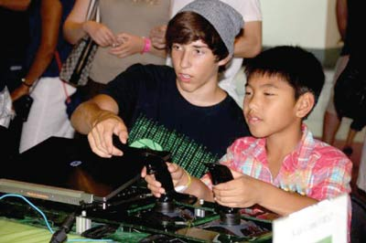
Submitted Photo -Team trainer Keith Rupp shows his trainee what to do.

Newton Robotics Team 3142 knows that the best way to help keep the United States in the forefront of science and technology is to educate the youth and get them excited about the sciences. With their Kids Come FIRST (For Inspiration and Recognition of Science and Technology) program and their robot, SnAperture, the high school robotics team did just that by spending a recent Saturday engaging youngsters at the Liberty Science Center in Jersey City.
Aperture, as the team is known amongst the FIRST robotics community, has been recognized as a leader in bringing awareness of the importance of STEM (Science, Technology, Engineering and Mathematics) to their community. The team was invited to continue their outreach by demonstrating their Frisbee-playing robot along with two other area teams at the science center. While Team 3314 — - Mechanical Mustangs’ robot tossed Frisbees for kids to catch, Team 56 — Robbe Xtreme and Team 3142 — Aperture taught kids how to operate robots at the drivers’ station. Aperture’s techno-green target board also gave the youngsters an opportunity to test their skills at target shooting.
The Kids Come FIRST program that Aperture has developed taps into various learning styles to ensure that kids get a real feel for what robotics involves. As each child sits at the drivers’ station, they receive instructions from the team
trainer. These instructions include how the controls are manipulated, what each joystick controls, how the robot will respond, and the subtleties of getting the Frisbee into the target. The auditory instructions are enhanced with visual cues as the team trainer demonstrates how the controls work.
Of course, the best part for the kids is getting their hands on the robot and making it move and shoot. Controlling the robot requires hand-eye coordination while at the same time kids must listen to instructions from the trainer.
For the trainer, the best part is seeing their young trainees get excited when the robot shoots the Frisbees into the target at their control. Hands go up, cheers are heard from the audience, and high-fives are exchanged. A sense of accomplishment, pride and huge smiles replace the look of intense concentration that just moments before graced these young faces.
While some visitors just want a chance to drive the 120-pound robot, Aperture members know that other visitors want a more comprehensive experience. A tradeshow area, set up by the team for visitors to walk through, greeted Liberty Science Center guests as they reached the
second floor. Team ambassadors wearing techno-green and black team colors welcomed the young visitors and their parents by presenting them with a team button. Buttons were pinned on the “new team members” who were invited to the team’s Kids Come FIRST activity table where they could gather crayons and activity sheets to work on after test
driving the robot and looking at the museum’s exhibits.
Veteran team members and trainers spent the day talking about the team, robot, and competitions and tried to answer the most commonly asked question from parents, “How can I get my child involved in robotics?”
Robotics is finding its way into high schools through FIRST Robotics Competition and robotics classes and middle schools through programs such as FIRST LEGO League and FIRST Tech Challenge.
To view more photos of the team at Liberty Science Center, learn more about the team, or become a sponsor, visit www.newtonroboticsteam.org.

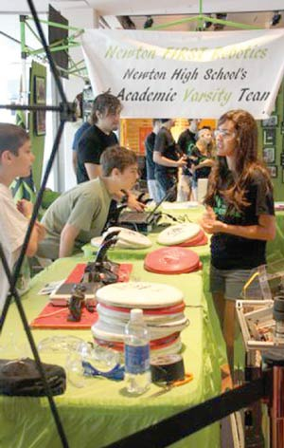
Submitted Photo - Team trainer Tess Bugay talks to kids about robotics.

