Kids come FIRST at the Liberty Science Center.
Published Aug 7, 2013 at 12:30 pm (Updated Aug 7, 2013)

Photos
- 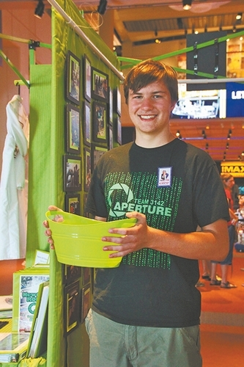
Team Ambassador Cameron Matulewski greets LSC guests at eh Aperture pavilion
NEWTON — Newton Robotics Team 3142 knows that the best way to help keep the United States in the forefront of science and technology is to educate the youngest and get them excited about the sciences.
With their Kids Come FIRST (For Inspiration and Recognition of Science and Technology) program and their robot, SnAperture, the local high school robotics team did just that, by spending the day engaging youngsters at the Liberty Science Center in Jersey City.
Aperture, as the team is known among the FIRST robotics community, has been recognized as a leader in bringing awareness of the importance of STEM (Science, Technology, Engineering, and Mathematics).
The team was invited to continue their outreach efforts by demonstrating their Frisbee playing robot along with two other area teams at LSC.
While Team 3314 - Mechanical Mustangs’ robot tossed Frisbees for kids to catch, Team 56 - Robbe Xtreme and Team 3142 - Aperture taught kids how to operate robots at the drivers’ station.

- 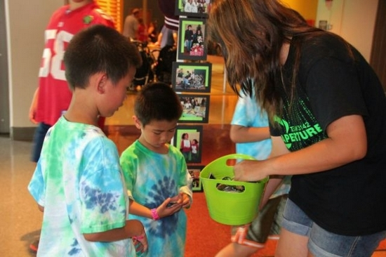
Team Ambassador Caitlin Bailey passes out team buttons
Aperture’s techno-green target board gave the youngsters an opportunity to test their skills at target shooting as well as driving.
The Kids Come FIRST program that Aperture has developed taps into various learning styles to ensure that kids get a real feel for what robotics involves.
As each child sits at the drivers’ station they use their auditory senses to receive instructions from the team trainer. These instructions include how the controls are manipulated, what each joystick controls, how the robot will respond, and the subtleties of getting the Frisbee into the target.
The auditory instructions are enhanced with visual cues as the team trainer demonstrates how the controls work. Then there is the tactile manipulation. Controlling the robot requires hand-eye coordination, while at the same time kids must listen to instructions from the trainer.
For the trainer, the best part is seeing their young trainees get excited when the robot shoots the Frisbees into the target at their control.
Aperture trainers also let their young trainees know the importance of their sense of smell. Being able to identify burning rubber and chemicals is important in safeguarding the robot and its technicians.
Aperture team members undergo a mandatory safety training session on the first day and learn that baking soda puts out electrical and chemical fires.
Throughout the day, guests at LSC witnessed team mechanics inspecting the robot and checking for hazards that could create a fire. Young guests learned what the mechanics look for, why they use a Kill Switch on the robot, and the importance of wearing safety glasses.
While some visitors just want a chance to drive the 120-pound robot, Aperture members know that other visitors want a more comprehensive experience and the team did not disappoint.
A tradeshow-like area, set up by the team for visitors to walk through, greeted LSC guests as they reached the second floor.
Team ambassadors wearing techno-green and black team colors welcomed the young visitors and their parents by presenting them with a team button.
A new button, it was explained, is created at the start of each season and is exchanged by teams during the various levels of competition. It is not an unusual site to see competitors walking around at competitions with hundreds of buttons pinned to their team apparel.
Not too long ago, robotics was a radical new course offered to graduate students at othe most prestigious universities specializing in technology. Now it is finding its way into high schools through FRC (FIRST Robotics Competition) and robotics classes and middle schools through programs such as FLL (FIRST LEGO League) and FTC (FIRST Tech Challenge.)
With the help of Aperture, even the very youngest are learning how much fun robotics can be and are being set on a path to becoming future STEM leaders.
To view more photographs of the team at LSC, learn more about the team, or become a sponsor, visit www.newtonroboticsteam.org.
- 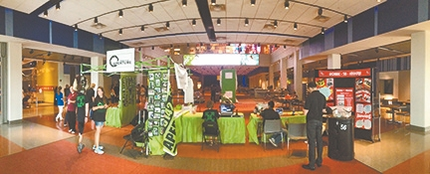
Aperture's display at the Liberty Science Center

