Awesome weekend for high school robotic teams
Posted: Mar 09, 2015 10:52 PM EDTUpdated: Mar 09, 2015 10:53 PM EDT

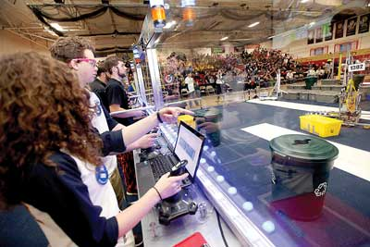
Photo by Tracy Klimek/New Jersey Herald - Pope John’s Lionheart robotics team members Evan Vengen, and Madison Langer use joy sticks operating their robot on Saturday at the Mid-Atlantic Region First Robotics Competition at Mount Olive High School.

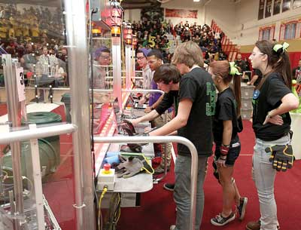
Photo by Tracy Klimek/New Jersey Herald - Newton’s Team Aperture members, Jacob Kolzow, front left, and Keith Rupp, back left, operate their robot as teammates Cassie Yauch, center, and Summer Malone, look on.
By BRUCE A. SCRUTON
bscruton@njherald.com
Two Sussex County high school robot teams were on the winning side that scored the most points in a single round of the FIRST robotics competition this past weekend at Mount Olive High School.
Newton High School's Aperture team along with Team Lionheart from Pope John High School teamed up with Pennsylvania's Tunkhannock High School's Tigertrons to score 132 points in one of the 92 individual rounds spread over two days of competition.
As a result of the competition, one of seven scheduled for the Mid-Atlantic Region, Newton is ranked 19th in the region with Pope John holding 57th place and Vernon's Viking Robotics ranked at 66.
Sponsored by FIRST (For Inspiration and Recognition of Science and Technology), each team is given six weeks to design, build and test its own robot to perform specific chores, but to also work with two other teams, selected for each round of competition in the round-robin event.
The top teams from qualifying events are re-grouped for the quarterfinal and semifinal rounds to determine the six teams which meet in the finals.
In the Mount Olive event, Newton finished 11th, making it into the semi-finals. Pope John finished 25th and Vernon was in 34th place.
There are seven events in the Mid-Atlantic Region competition with teams pre-selecting two of those events for qualifying scores. Teams can also participate in an event, but without getting a score.
The top three teams at each event automatically qualify for the regional championships, to be held at Lehigh University in Bethlehem, Pa., next month.
Teams can also qualify by winning one of the top team awards given at each event and by their ranking at the end of regional qualifying.
At the Mount Olive event, Newton picked up the Creativity Award, sponsored by Xerox, however that award is not a qualifying award for the regionals.
World finals in St. Louis
Each of the three Sussex County teams have another event in which to gain enough points to qualify.
Winners at the regional event go on to the world finals in late April in St. Louis.
“It was a tiring, but successful and awesome weekend,” said Darleen Nelson, a co-coach for Newton.
This year's robots are competing in an event known as Recycle Rush, a recycling-themed game where robots score points by stacking totes on various platforms. The first 30 seconds of the competition, the robots are to operate on their own, with student controllers taking over for the rest of the competition, working with the other two teams on their side in a race for points against three other robots.
Once totes are stacked, they must be capped with recycling containers.
“That has to be done correctly because it could tip over and you have to start stacking again,” said Nelson.
Recycling theme
Along the way, the robots must also properly dispose of litter, represented by foam pool noodles, to get extra points. Because of the recycling theme, all parts for the robots must be reusable or recyclable by teams or by FIRST at the end of the season.
“This year's robot is doing exceptional,” said Nelson, who is co-coach along with James Hofmann, who began the robotics team at Newton several years ago.
The program is geared for the high school students getting a chance to work with mentors from various companies or organizations, whether they be engineers, scientists or craftsmen.
Teams also get involved in the arts with side projects based on the year's particular robot theme.
Teams have a set budget they must work with and can have as many team members as they want.
Nelson said Newton's team this year has a roster of 29 students, “with a steady core of about 25 that show up to work.”
Newton's next event will be the weekend of March 27-29 at Bridgewater High School.
Bruce A. Scruton can also be contacted on Twitter: @brucescrutonNJH or by phone: 973-383-1224

