New Jersey Herald 1/11/15

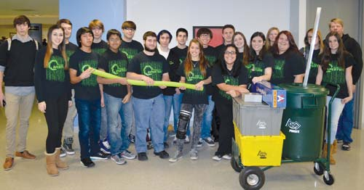

Photo by Darleen Nelson — The Newton High School robotics team was one of 35 teams on Jan. 3 at NJIT to begin the First Robotics Competition season.

Newton Robotics attends kickoff
Posted: Jan 10, 2015 6:26 PM ESTUpdated: Jan 10, 2015 6:26 PM EST
NEWTON — On Jan. 3, about 30 Newton High School robotics team students celebrated the new year with the kickoff of the First Robotics Competition season.
FIRST, short for “For Inspiration and Recognition of Science and Technology,” was founded in 1989 by Dean Kamen, the inventor of the Segway.
Newton Robotics Team 3142, also known as Aperture, was one of 35 teams at the New Jersey Institute of Technology in Newark, which was just one of 107 kickoffs worldwide that 2,917 teams were involved in. These local kickoffs have many purposes such as sharing ideas and designing new robots; however, the main purpose is to watch a live broadcast that explains the new season and the challenge that the robots must overcome.
The new season started with numerous seminars on specific aspects of robotics. Some of these topics were safety, mechanics and electrical engineering. The broadcast explained this year's game as “Recycling Rush.” Teams are to build robots that can stack recycling bins and throw “litter” into recycling bins to complete this challenge. To gain extra points, one team can throw the litter on an opposing team's side of the field. This new challenge connects with real life situations more than the challenges of previous years because recycling is actually necessary to help the environment.
Each team has six weeks to build robots that can efficiently complete the goals of the season. After the conclusion of these six weeks, the robot is bagged and tagged and cannot be touched until competition.
This year, Newton Robotics Team 3142 Aperture's first competition is in Mount Olive on the first weekend in March.
For more, visit the team's website at www.newtonroboticsteam.org. For questions or contributions, email newtonroboticsteam@gmail.com. Like the team on Facebook at Team 3142: Aperture.

