Newton Robotics begin new season

Designing robot for Recycle Rush challenge

PUBLISHED JAN 14, 2015 AT 1:45 PM (UPDATED JAN 14, 2015)
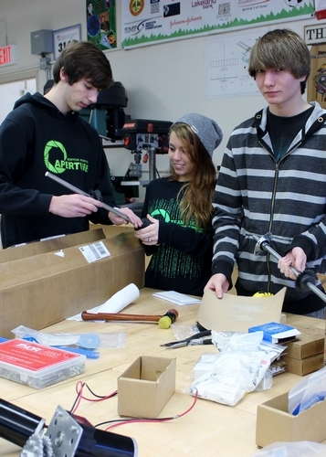
Newton Robotics Team Design Leader Keith Rupp, Strategy Leader Cassie Yauch and Build Leader Jake Kolzow

NEWTON — Earlier this month, the Newton Robotics team 3142 attended the FIRST Robotics Competition kickoff at the New Jersey Institute of Technology.
The kickoff included an offering of seminars, including safety, tips for speaking with the competition judges, and electrical engineering. In addition, the 2015 challenge was announced.
The challenge for this year is Recycle Rush. The goal is to build a robot that can stack totes, put a pool noodle in a recycling can, and put the can on the top of a stacked tote tower. It marked the beginning of week one of six in the build season for Newton.
The design team worked throughout the week to develop a strategy and a design for the robot. After much brainstorming, the team has chosen a design for the robot and is beginning to utilize the computer in designing its parts.
When asked to describe the week using a few adjectives, many of the team members called it tiring and fun, but most of all, everyone considered the week to be productive.
Students said that a lot of work had been accomplished.

