Newton students use 3D printer to design locker handle for disabled freshman
Posted: Dec 22, 2014 11:49 PM ESTUpdated: Dec 22, 2014 11:49 PM EST

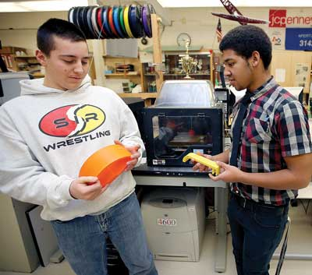
Photo by Tracy Klimek/New Jersey Herald Newton High School junior Robert Borgognoni, left, and senior Justin Hermann, right, hold prototypes of handles for a locker that they designed on the 3D printers in teacher Brian Bennington’s class.
By GREG WATRY
gwatry@njherald.com
NEWTON — Justin Hermann, a senior at Newton High School, was walking in the school hallway when he noticed a freshman student struggling with her locker.
The 17-year-old Hermann said he realized that the student and special education teacher Liz Fusco weren't just trying to open her locker, but were trying to figure out a way that the student could accomplish the task with ease in the future.
“That's when I kind of came up with the idea,” he said.
Utilizing the 3D printers available to him through his advanced principal design class, Hermann, along with junior student Robert Borgognoni, made a plastic modification for the student's locker.
At Newton High School, the lockers are designed so that students have to pinch the handles and lift them up in order to open them. The student's physical handicap, according to technology teacher Brian Bennington, doesn't allow her hand the dexterity to perform such a task.
The plastic locker cover was placed over the locker handle. “What is keeping it attached to the locker is a bolt that goes through one side and is buried into the other side,” according to the design schematics. “The person can simply pull on the handle attached to it. They no longer have to worry about the latch.”
“She's not the kind of girl that would ask for something like this,” Fusco said. “But I think it made her feel
special.”
Hermann was the idea man, while 16-year-old Borgognoni manned the computer and designed the plastic cover in the computer program SolidWorks.
“We went through multiple prototypes,” said Borgognoni. All in all, it took the duo three weeks of design to produce the final product.
The final print took almost a full day, said Bennington.
According to the two students, the device has been in place since the start of November.
“It's very futuristic,” Borgognoni said of the entire process.
The whole process “opened my eyes to what we can do” with this technology, said Hermann.
All the student has to do is slip her hand in the device, pull and the locker opens, he said.
The locker is kept shut through magnets that were installed in the locker.
Newton High School is home to two MakerBot 3D printers.
The availability of the machines is making students think differently, according to Bennington. Students are voluntarily exploring new ideas, rather than being coaxed into the school work.
“For a teacher, that's like a dream,” he said.
And the 3D printing isn't limited to one of the school's departments. According to Bennington, the 3D printers were recently used to produce a trumpet mouthpiece for the music department. “The thing worked so beautifully. I couldn't believe it,” he said.
With 3D printing, the future is unwritten.
“This project made me realize that what I want to do is open up my own company for biomedical engineering,” said Hermann. “What I want to do is mass produce products and inventions to help handicapped people.”
Borgognoni wants to pursue engineering though he is unsure what kind.
For Fusco, herself a Newton graduate, Hermann and Borgognoni's actions highlight the compassion that permeates throughout the student body's population.
“It's really a family here at Newton High School,” she said.

Greg Watry also can be contacted on Twitter: @GregWatryNJH or by phone: 973-383-1184

