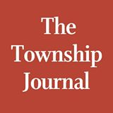

Newton Day draws huge crowd
BY LAURIE GORDON
PUBLISHED JUN 15, 2015 AT 2:22 PM (UPDATED JUN 17, 2015)

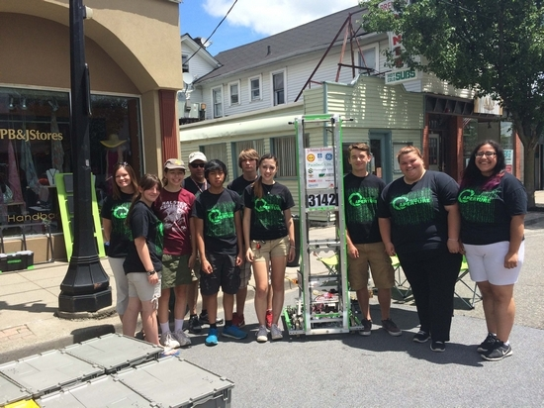
Photo by Laurie Gordon Newton Robotics Team showing off their robot.

NEWTON — Spring Street transformed into a carnival on Saturday as the Annual Newton Day Festival sprung to life beckoning residents and out-of-towners alike to join the festivities.
Events started at 11 a.m. on Spring Street featuring all kinds of vendors, acts, demonstrations and music. The Newton Robotics Team was on hand to show off their robot that's gained them national fame.
“We love being out in the community and showing off our hard work,” said one of the team's leaders, Newton High School junior Lara Pennell.
Vendors sold everything from a smoking Liquid Volcano drink to clothing, jewelry and a whole lot of food. A dunking booth gave kids the chance to dunk their favorite teacher, principal, coach or police officer, and One Step Closer Animal Rescue (OSCAR) held a pet adoption. Giveaways included a membership to the Newton Town pool and free ice skating at Skylands Ice World.
Little kids present delighted in a merry-go-round safari ride, and shows on a stage set up half way down Spring Street included Mad Science and Rizzo's Reptiles.
Corinne Renshaw, a 12-year old who attends the Northwest Christian School bopped through town with a big smile on her face.
“Everything at Newton Day is perfect,” she said.“There are so many new things to see, taste, and buy and the amazing fireworks finish it off.”
On the town green, period re-enactors could be found and at the McGuire's parking lot, there was a classic car show. At 4:30 p.m, the celebration continued at Memory Park for old-fashioned field games, inflatables, hayrides, more vendors and food, and things capped off with a fireworks display put on by Garden State Fireworks.
The event is a collaboration between the Greater Newton Chamber of Commerce and the Town of Newton.

