Newton High School team puts robot through its paces
Posted: Feb 20, 2015 12:23 AM ESTUpdated: Feb 20, 2015 12:23 AM EST

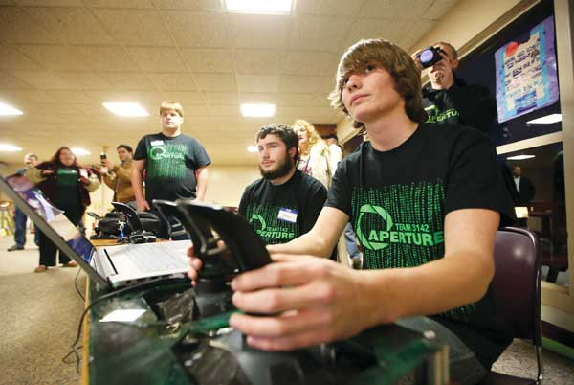
Photo by Daniel Freel/New Jersey Herald Newton High School junior and robotics team member Jake Kolzow, right, drives the group’s stacking robot and teammate Brian Hoskins operates the lifting mechanism as the group demonstrates the robot.
By GREG WATRY
gwatry@njherald.com
NEWTON — In the senior lounge of Newton High School, a group of students, parents and public officials watched in awe.
Before them a robot picked up containers that sat in a line on the floor. Each container was hooked by teeth-like tongs and lifted up, making ample room for the next container in the line.
The robot, controlled by junior Jake Kolzow, 16, placed the stacked containers on the ground and fetched the dark green recycling can. It finished the demo by laying the can atop the container tower.
On Thursday night, parents and sponsors of Aperture — Team 3142, Newton High School's robotics team, came together for the robotics team's fourth annual STEM Night.
“It's a night for our parents to come in and our sponsors to see what it is that we've been doing for the six weeks of build season,” said sophomore Katie Nelson, 15.
The 2015 FIRST Robotics Competition's game is called “Recycle Rush.” Played by two alliances of three robots, the game is scored “by stacking the totes on scoring platforms, capping those stacks with recycling containers, and properly disposing pool noodles, representing litter,” according to FIRST's website.
“The challenge itself is very difficult,” said junior Lara Pennell, 16, the team captain. “It seemed very difficult to pick up totes and then place a trash can on top of it,” but “we came up with this lift design. It's amazing.”
Newton's robot has two drivers, Kolzow said. “We have one driver doing the mechanical driving” with two sets of joysticks. A second driver controls the robot's auxiliary functions, which include the lift.
Coach Jim Hofmann, a technology teacher at Halsted Middle School, praised the students for their work during the build season.
“You know you're doing something right when you have 40 students hanging with you on a Saturday,” he said. “They love being here.”
“Student team members designed, sketched, thought of, researched, modeled, prototyped, argued and found common ground, and then they began to build,” Hofmann added. “I challenged them after the kickoff to create an amazing machine and they did that.”
The team will compete in two district competitions, one in Mount Olive during the first weekend of March and another in Bridgewater. Based on how the team places or if it wins either the Engineering Inspiration Award or the Chairman's Award, it moves on to regionals in Bethlehem, Pa. From there, the team has the opportunity go to the international competition in St. Louis, Mo.
“It's definitely amazing what we can do and we're all (students) doing it,” Pennell said.
Project manager and game strategy leader Cassie Yauch, a 17-year-old senior, said being involved in the robotics team changed the course of her life. Originally, she had ambitions to become a forensic scientist, but now she wants to study to become a mechanical engineer.
Kozlow, who has ambitions of becoming a robotics engineer, said, “Participating in FIRST has just given me a great opportunity to get my hands into the mechanical aspects of building robots and programming robots.”
The team is optimistic about its chances at the upcoming competitions, and Superintendent Kenneth Greene lauded the robotics program.
“A lot of what we do in the school district is set by adults,” he said. “This is a very different type of operation that is sprung from the (students).”
“Practice is over,” he added. “It's time to play the game, as they say.”
Greg Watry also can be contacted on Twitter: @GregWatryNJH or by phone: 973-383-1184.

