Newton Robotics team building 'Pit' computers
PUBLISHED FEB 19, 2015 AT 2:55 PM (UPDATED FEB 19, 2015)

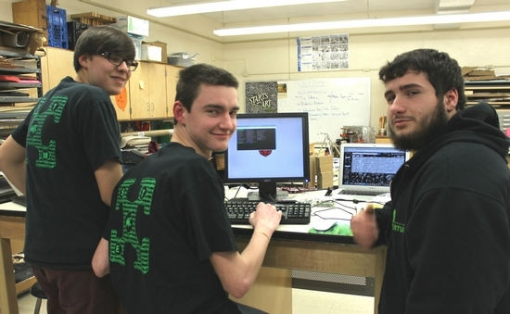
Team 3142 Newton Robotics Team programmers Cameron Osborn, Michael Groschadl and Brian Hoskins.
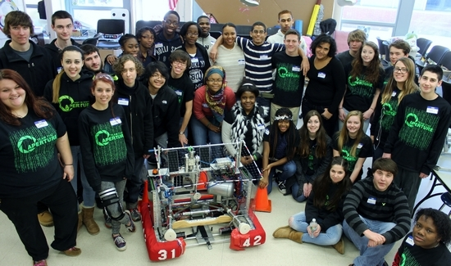
Newton Robotics Team hosts a mentoring meeting for East Orange Team 5310.

NEWTON — The Newton High School Robotics is up to RaspberryPi, a series of credit card-sized single-board computers that are used for video and photo presentation on monitors.
These monitors are used in the team’s pit.
At robotics competitions “the pit” is just like in NASCAR where the robot rests and gets a tune up between matches. The pit has all the team’s tools and materials that could possibly be needed in case of a “crash” or malfunction.
The pit is also ideally set up in a way that bests represents the team and the current years challenge.
This year the global challenge is titled “Recycle Rush” and the idea is to incorporate and educate about recycling in as many parts of the competition as possible.
For more information see the team’s webpage www.newtonroboticsteam.org.

